CRM: Application used to automate sales, marketing and service activities in an organization.

ERP: Manage resources (finance, HR, Procurement…) 360 View: To see all data about your customer.

An app to manage all the customer data and details and to increase sales.

Lead: Potential customer.(may become an opportunity)

Activity: Action to be created or be performed on entity (like send email to customer).

Task: Generic activity.

Business Entity: An Entity is part of Microsoft Dynamics CRM default installation (like contact or account) also it is called out of the box on the other hand there is custom entity.

Business Unit: A business, Division or departments (like creating department it is used in setting security roles for example).

Contact: Represent individual customer.

Account: Represent corporate customer like company.

Opportunity: Potential Revenue generating event also you can say that opportunity is a more qualified version of lead.

Product: List of products. Competitor: List of your competitors.

Queue: Logical grouping of work items like queue of cases or tasks.

Security Role: User permissions on system, it is very important.

User: Login user on CRM.

Classic interface

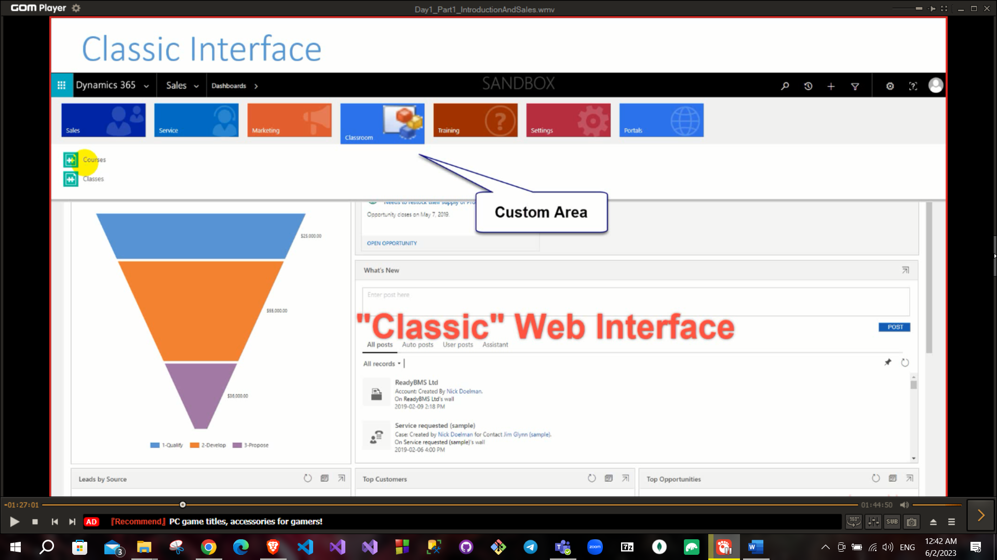

Now we will use UCI (responsive and supported) after 2016

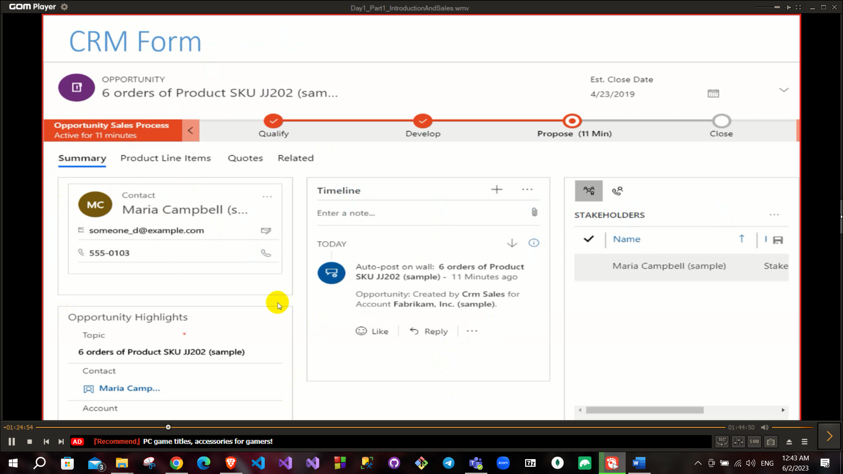

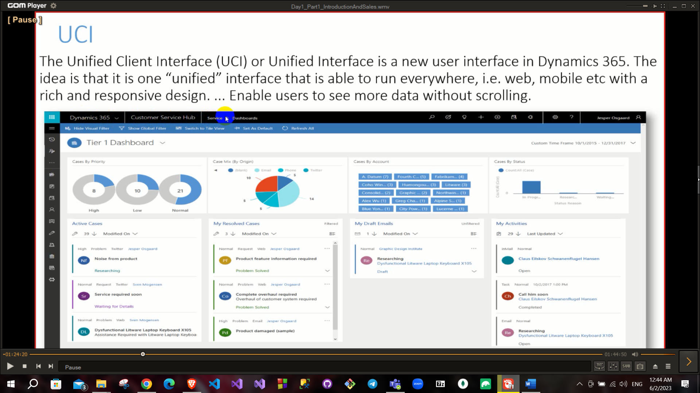

Integrated application with CRM XRM (X for any custom application) RM

CRM may be cloud on premises (3la el server 3ndy)

It was a desktop app but Microsoft bought and made it a web based app and it became Microsoft dynamics.

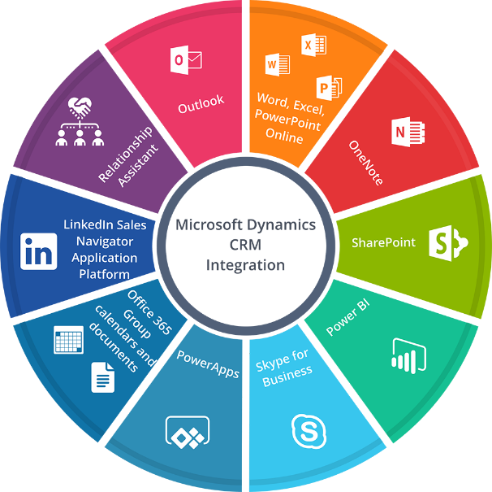

Apps that integrates with crm:

XRM is any relationship management  
we can use crm in any application

Xrm (it means that it can manage any thing) infinity possibilities.

Used in any system in banks, schools, ……

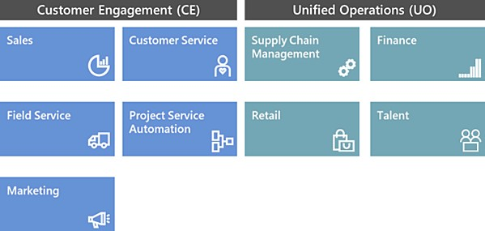

**First Module(Sales)**

# Sales Management elements:

* Lead Management(any details I take from someone that I see that may be he will be opportunity)
* Activities(any thing that you will make to make sure that this lead is interested and make sure he is an opportunity like calling him)
* Account and Contact(account->corporate, contact->individual)
* Opportunity
* Sales Process
* Quote (like offer you offer your price for opportunity).(عرض سعر)
* Order
* Invoice (bill of this sales process).
* Product
* Price List (if you have more than price to your product for different currencies).

First we go to the environments

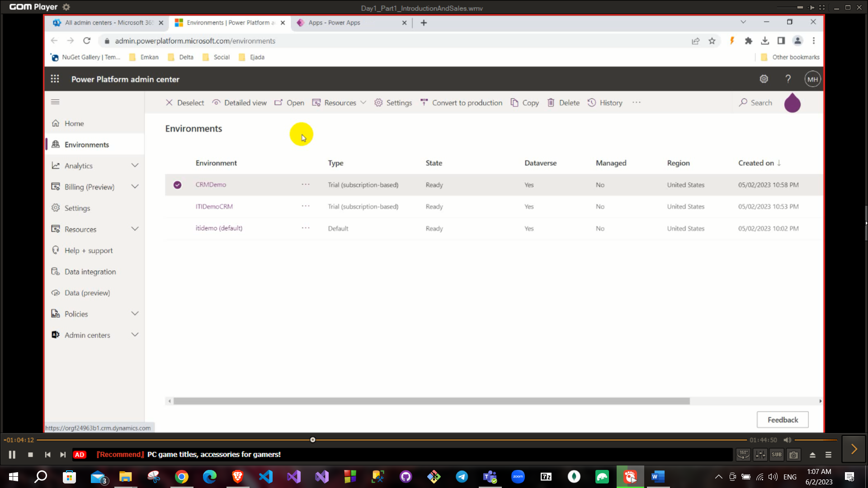

And if you open an environment you can see its details

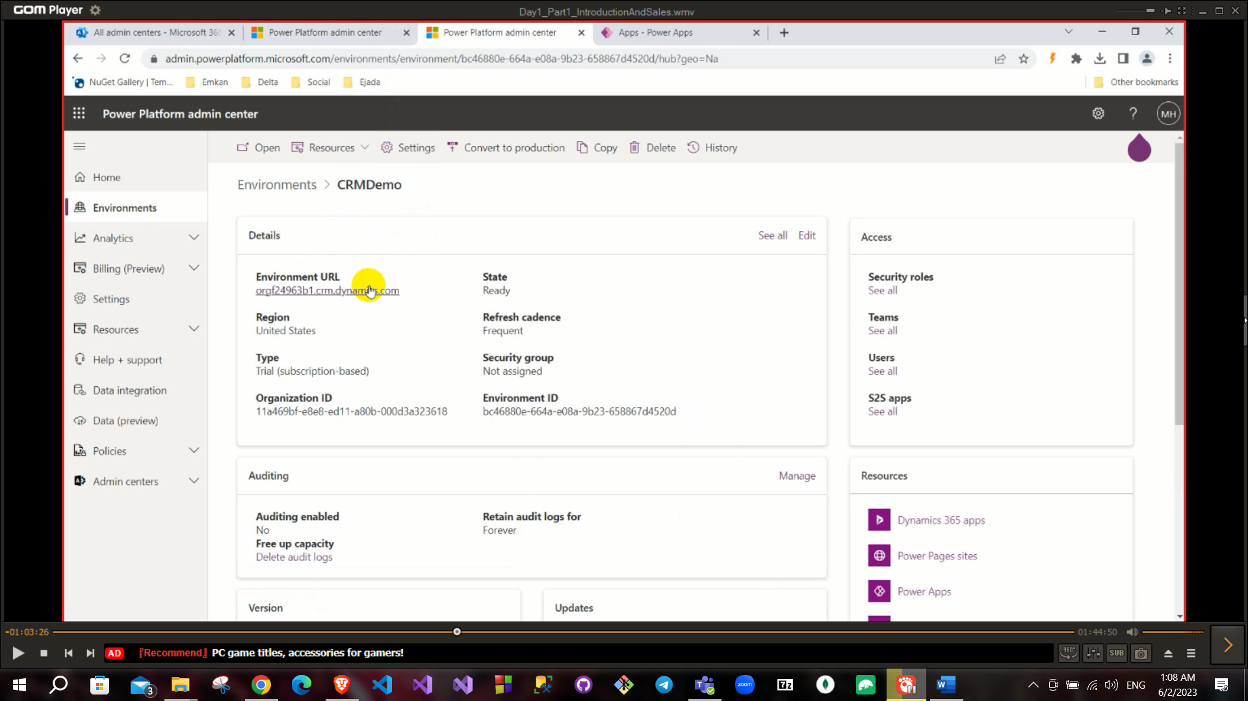

At the bottom left there is the admin center and when we open it:

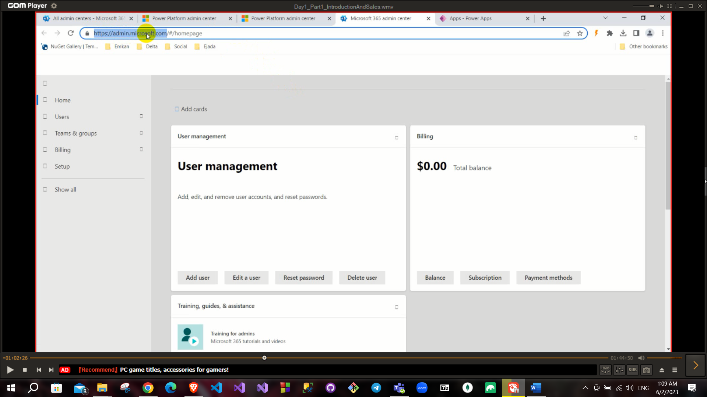

And if you go to all admin centers

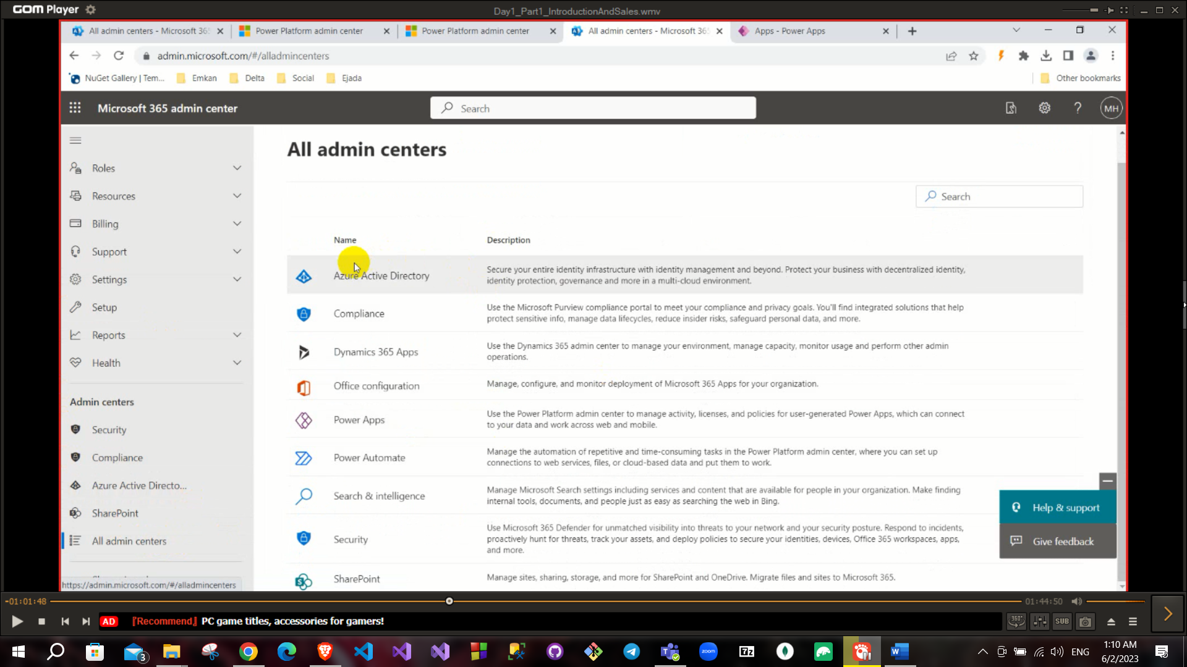

You can create an environment

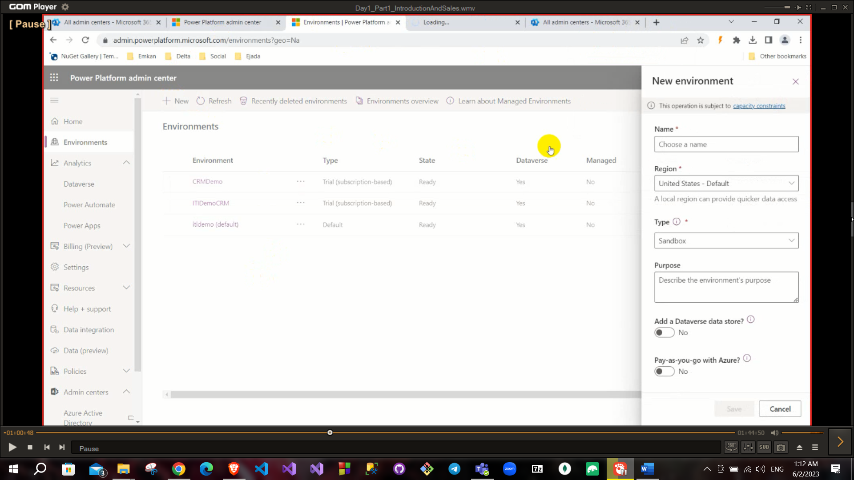

This is an environment

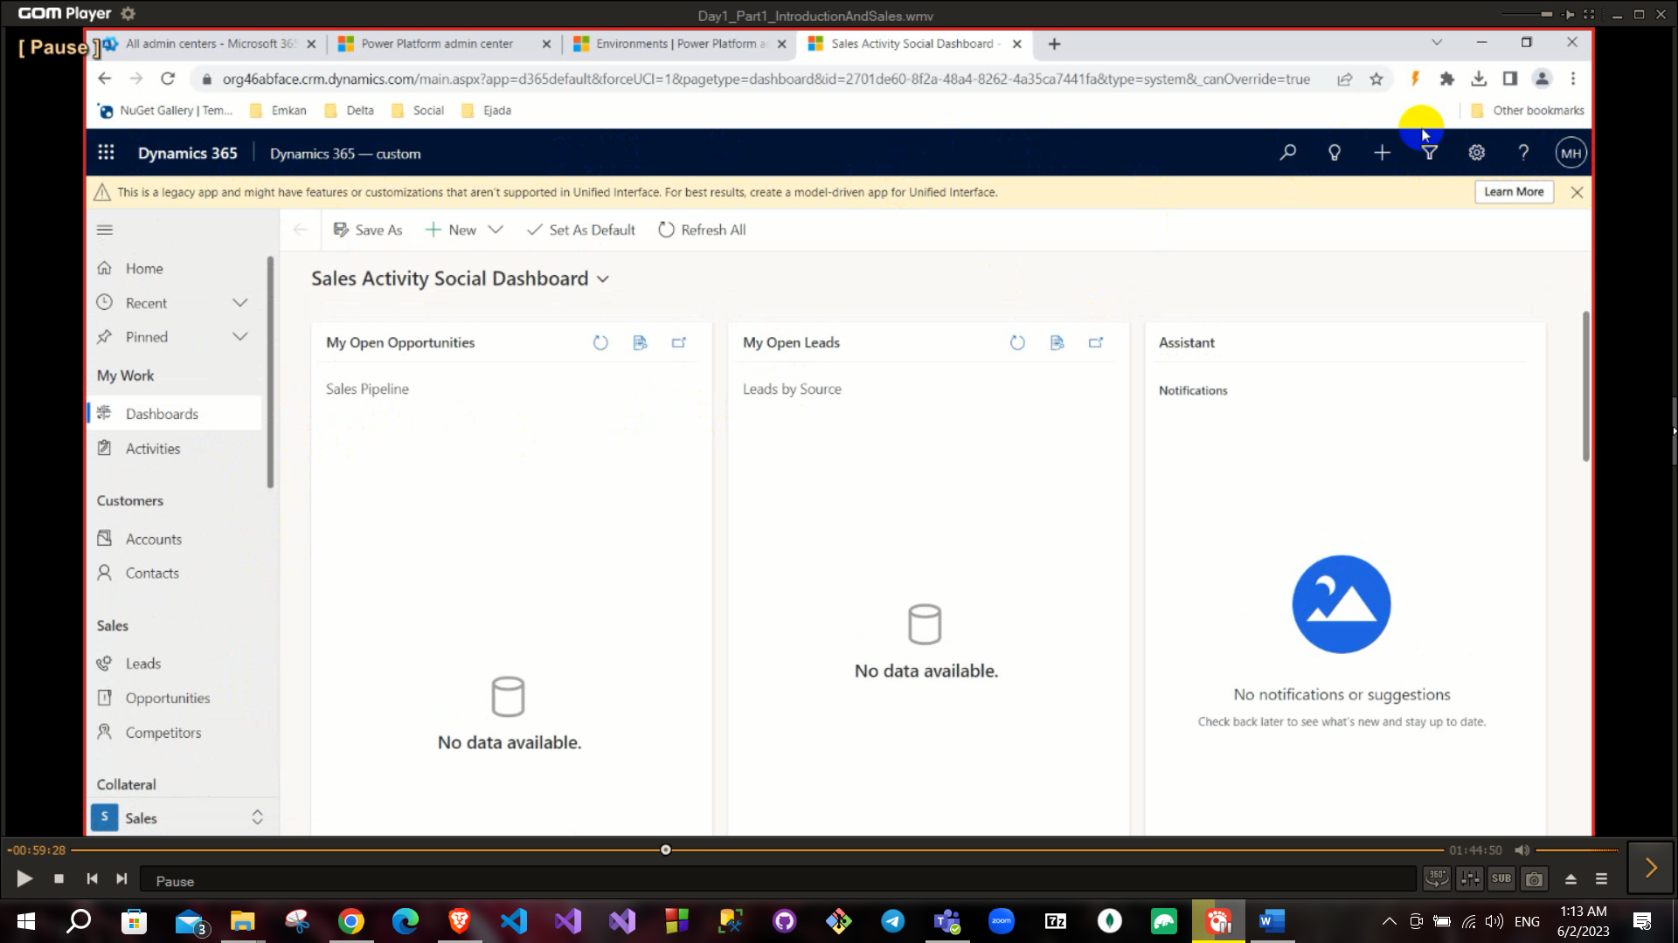

Sales Process (lead → Qualify → Development →Propose →Close) It like a pipe line of my process.

When you click the lead entity , this is called view

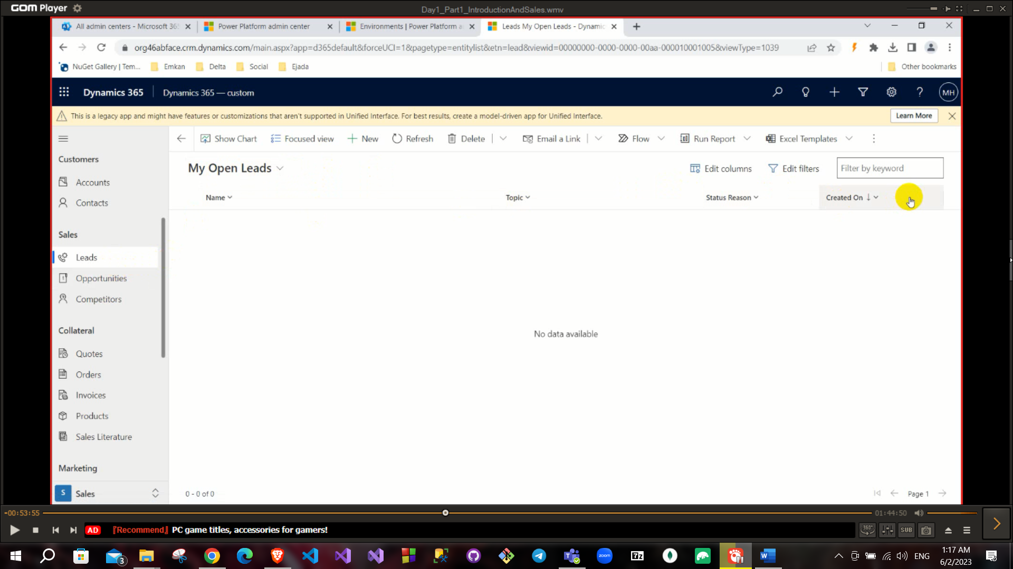

The buttons above are called ribbon buttons

When we click new

This is called Form

And the summary, details and files these are tabs

The contact is called a section

Inside the section these are fields

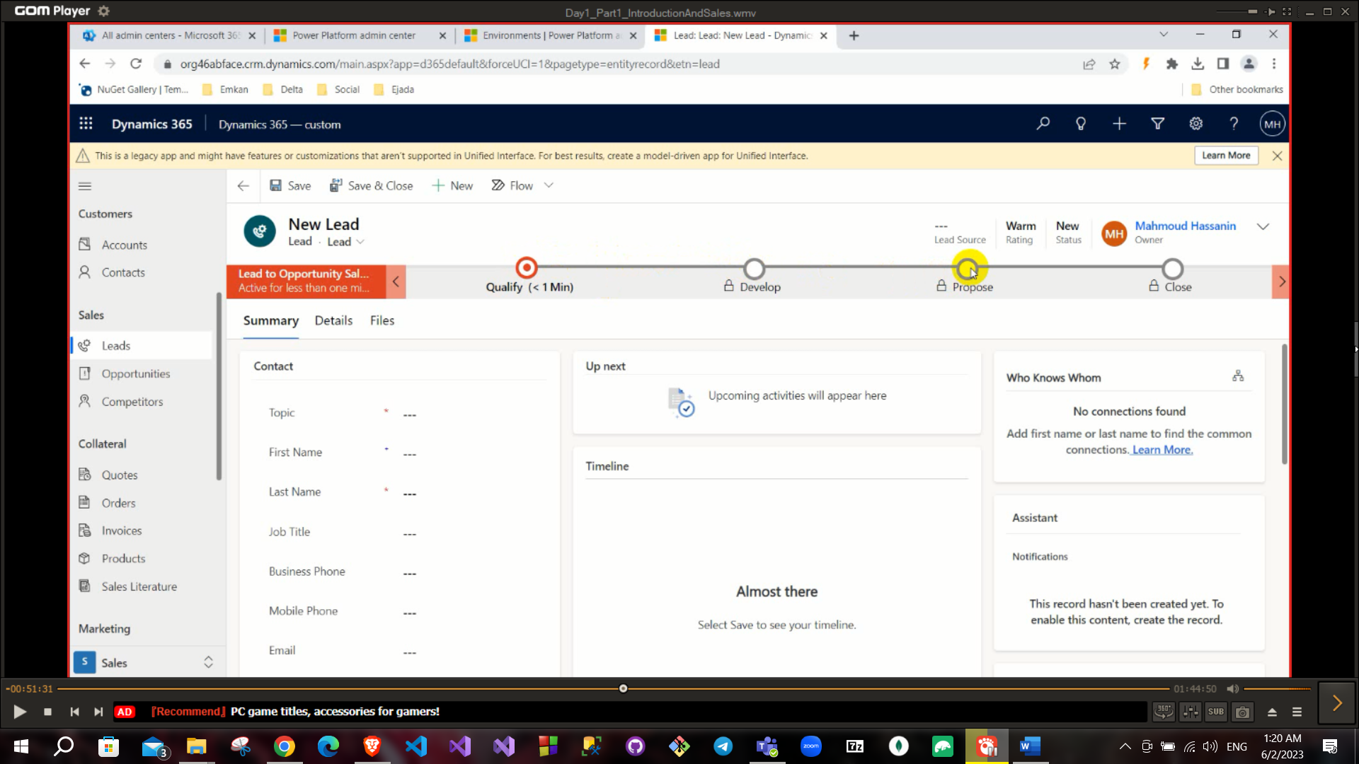

Above we can see all the lead stages.

It is important to know difference among (Entity, Field, View, Form, Tabs).

* Entity: An entity is a representation of a business object or concept, such as a customer, order, or product. Entities are used to store and manage data in Dynamics CRM.
* Field: A field is a property of an entity that stores a specific piece of information. For example, a customer entity might have fields for the customer's name, address, and phone number.
* View: A view is a defined way of looking at data in an entity. Views are used to display data in a specific format, such as a list or a table, and can be customized to show only the data that is relevant to the user.
* Form: A form is a user interface that displays data for an entity. Forms are used to view, edit, and create new records for an entity. Forms can be customized to show only the fields that are relevant to the user.
* Tabs: Tabs are used to organize the fields on a form into logical groups. Tabs can be used to group fields by category, such

as contact information or billing information.

All the entities(الجاهزة) at the left they are called out of the box.

Any requirement I will try to find an out of the box entity that can do it, if no then we go to the customized

If you see (Active button or Publish button) click on it immediately.

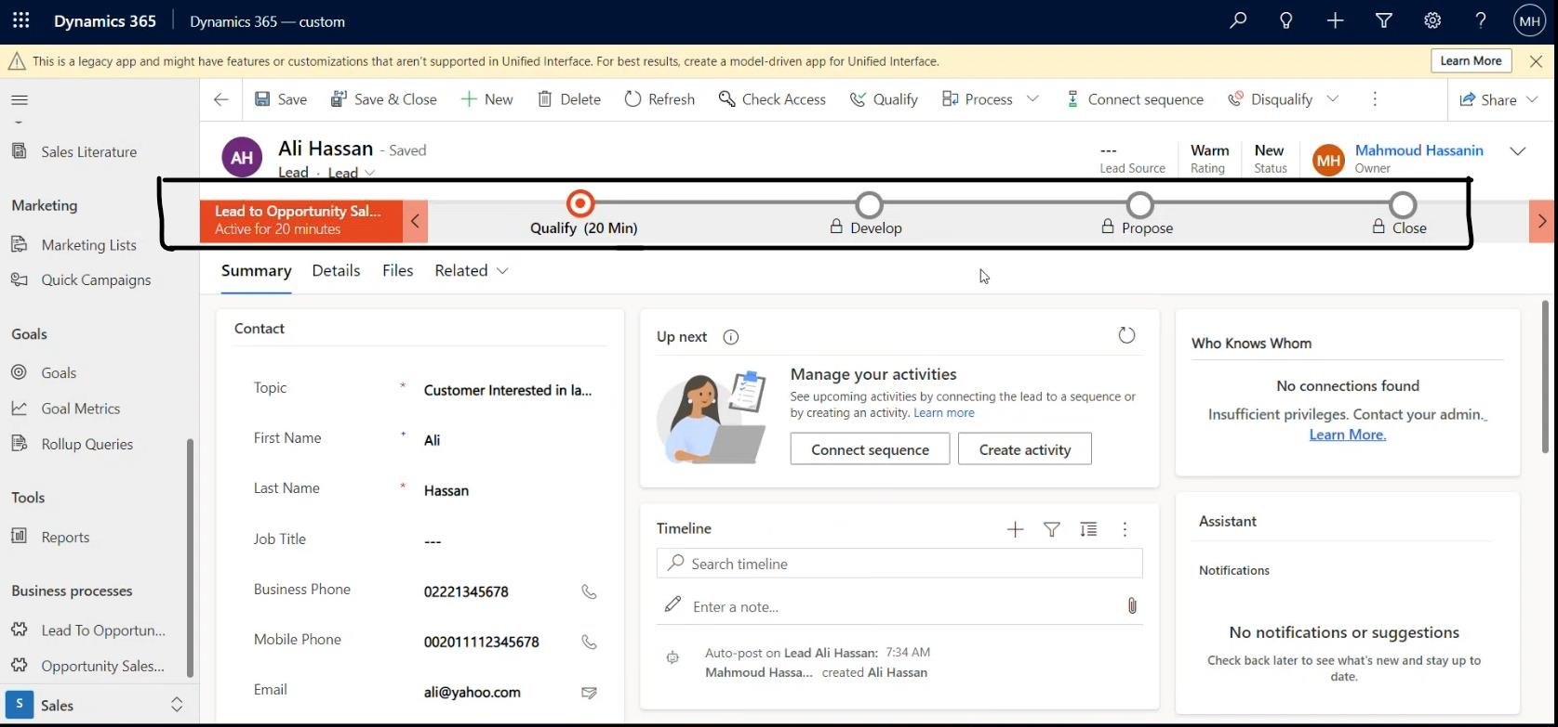

Click save and you have created the lead.

After the lead is created and the sales team connects with the lead now they have to fill some info to qualify him

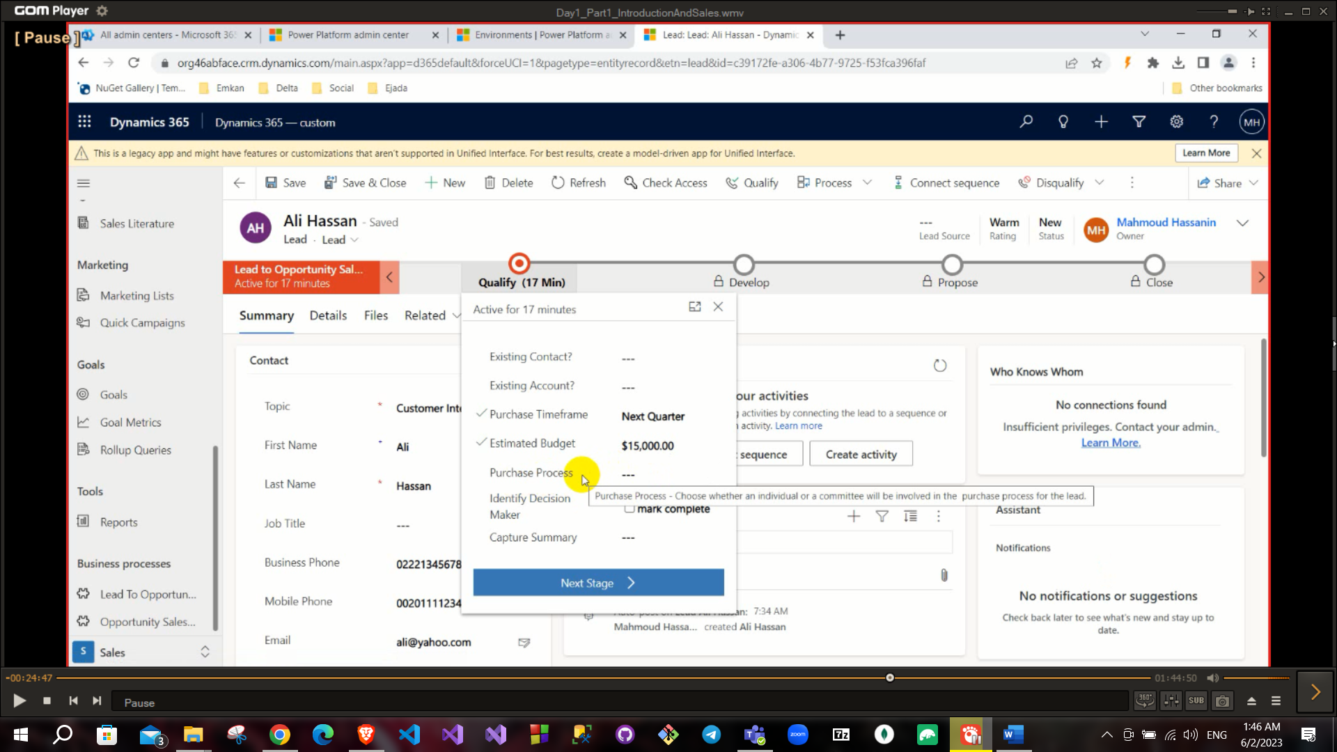

To qualify the lead and go to the next stage there must be an opportunity

**You can set a note on lead in timeline field.

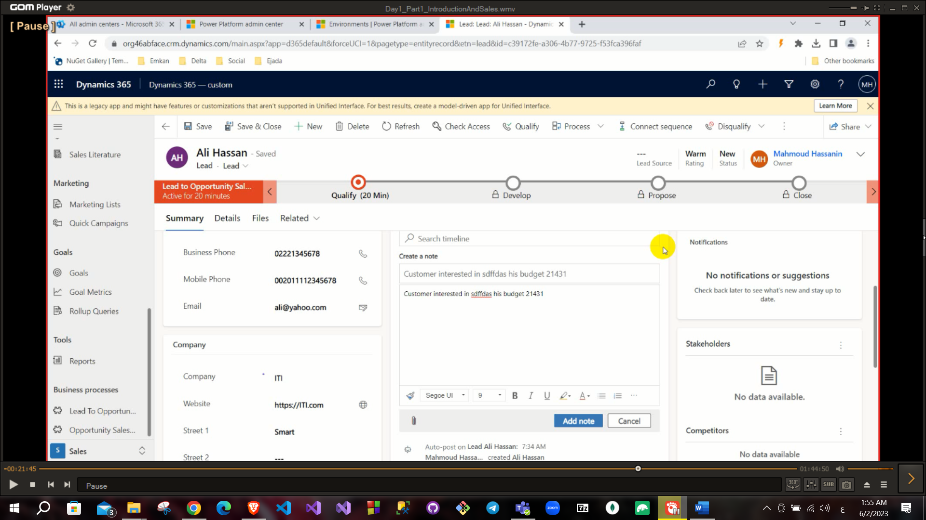

Also on the time line we can create activity to the lead

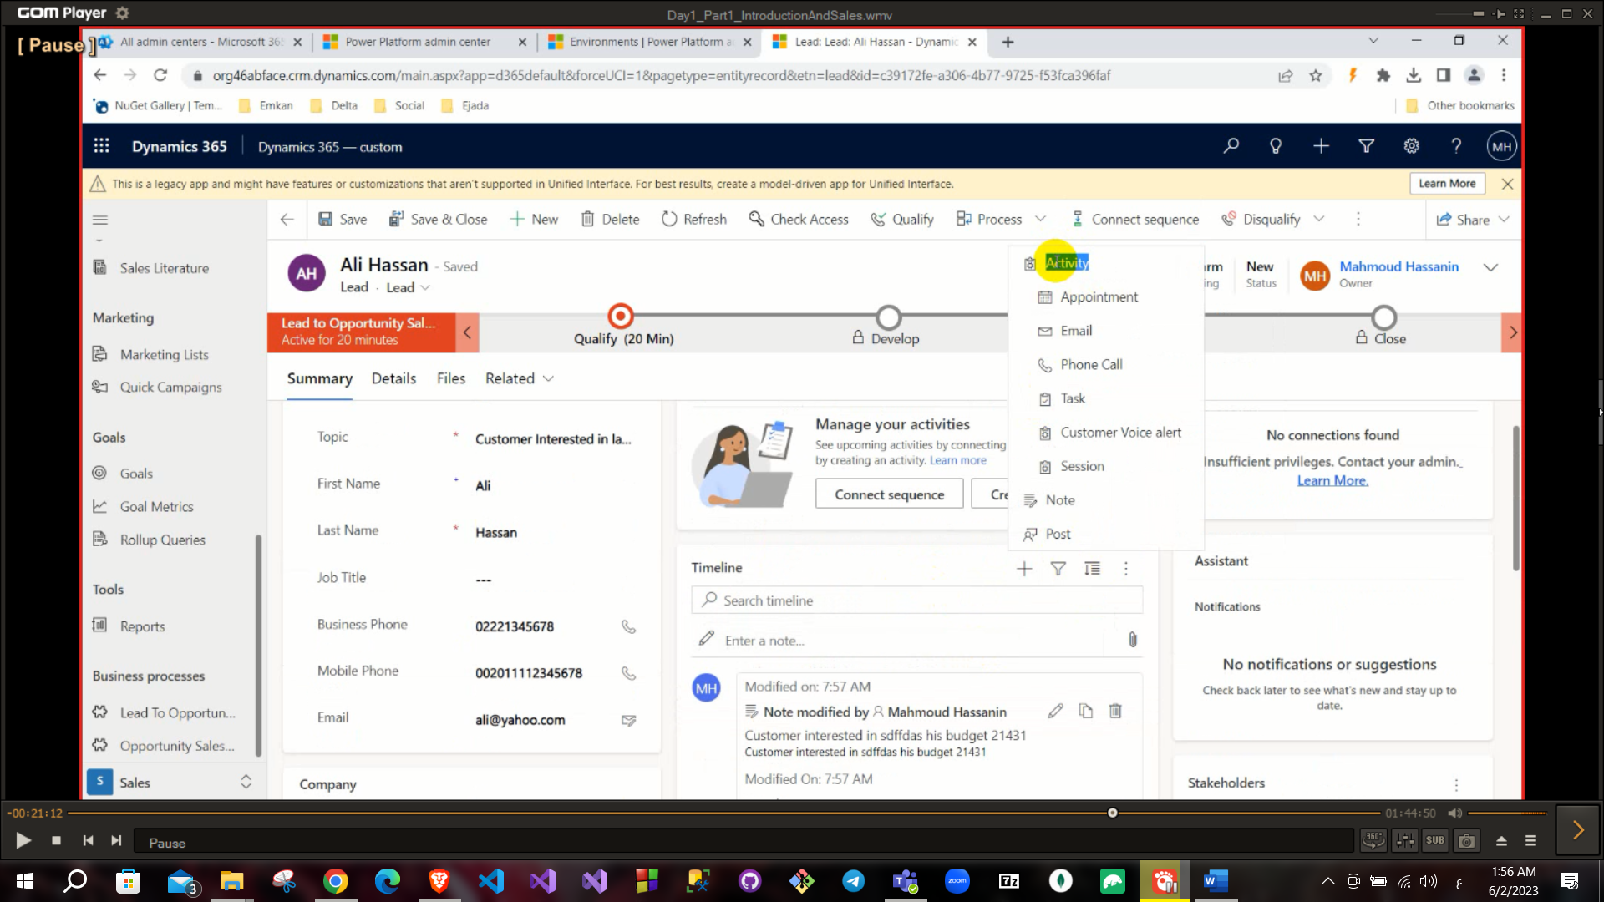

The form header:

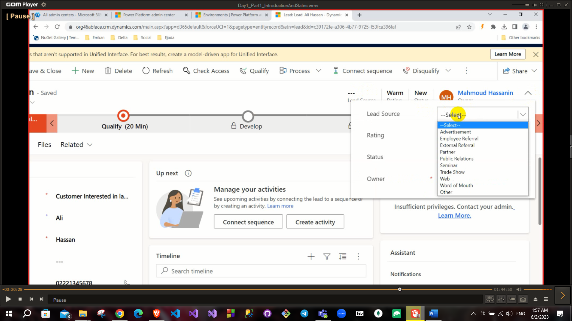**Lead source: where did this lead come?

Also you can click qualify and it will create the opportunity, contact and account

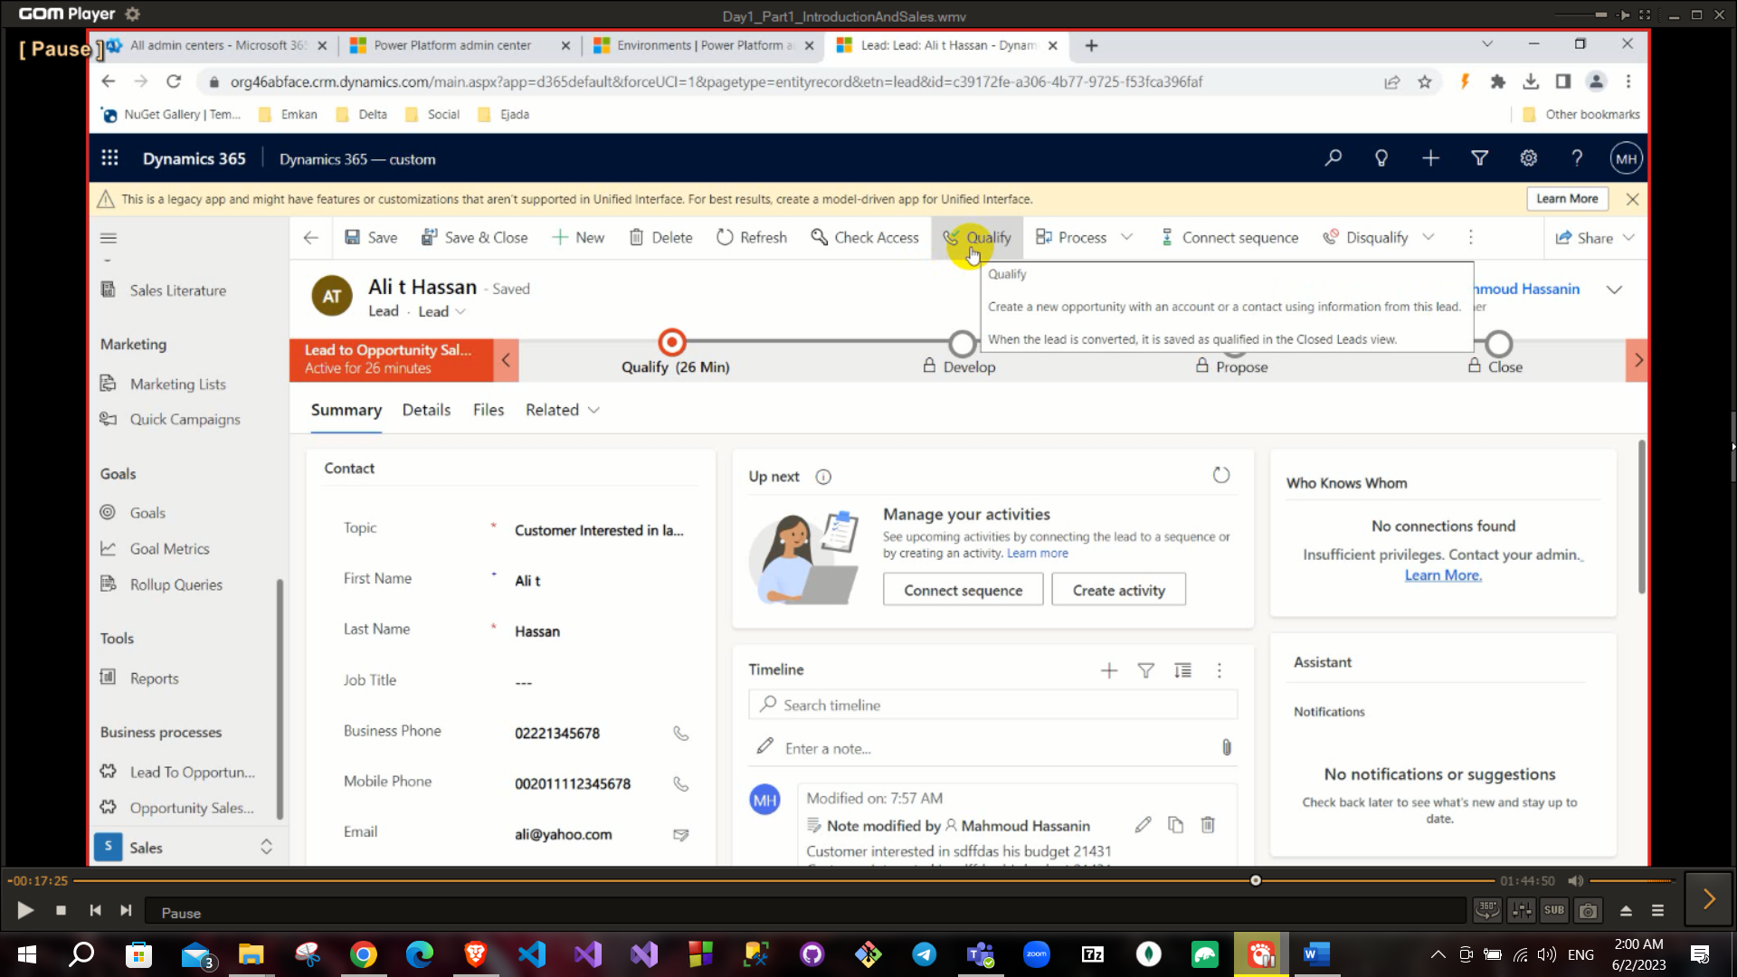

**You can create an opportunity without creating Leads.

**Disqualify: close this lead and put reason of closing it (Lost, Cannot contact, No longer interested, Canceled).

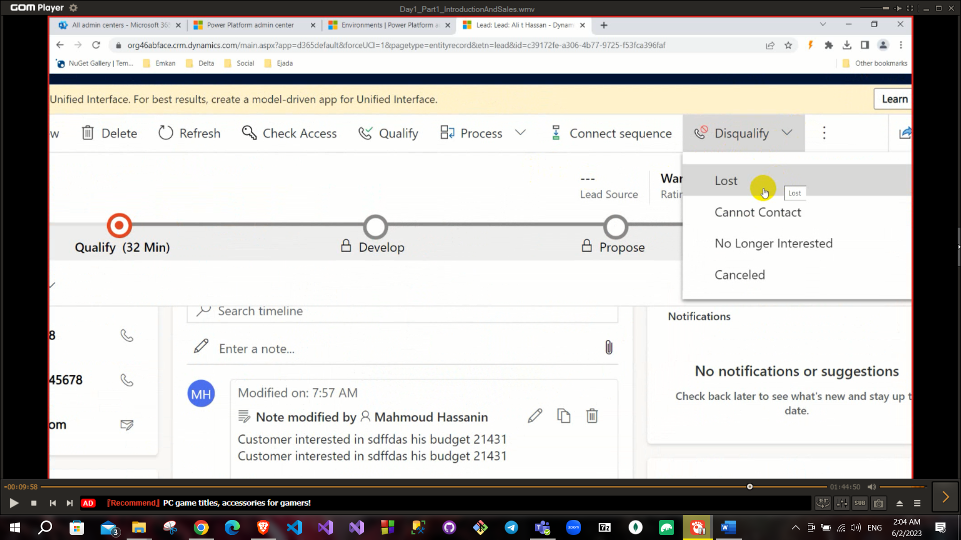

It is important to set disqualification reason to build your dashboard data. When you qualify a lead there are three events will be occurred:

1. Create Contact if not exists.
2. Create Account if not exists.
3. Convert this lead to opportunity.

If you get a required in CRM you should to take these steps

1. Use out of the box business entity.
2. Use Custom entity (create your own entity).
3. Use JS (client-side Customization).
4. Use Custom work flow or Plugin.

**Merge record will merge all these entities into one record.

**Chart in Dynamics is interactive chart.

**Lookup is a reference for another record in my record.

After pressing qualify ribbon now we get to the next stage

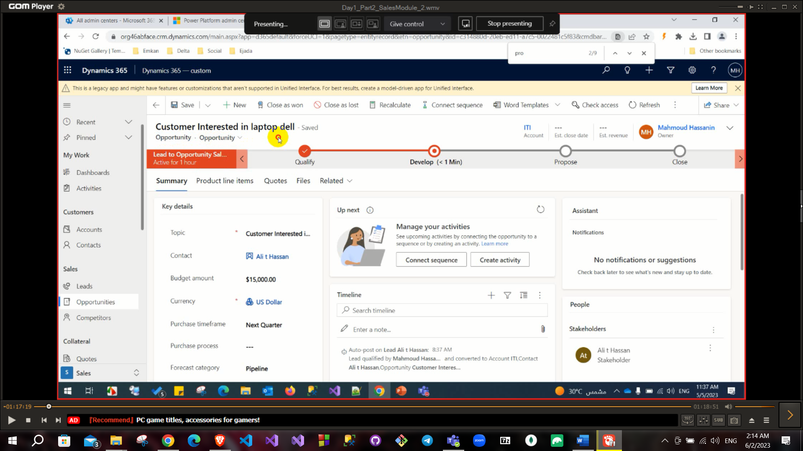

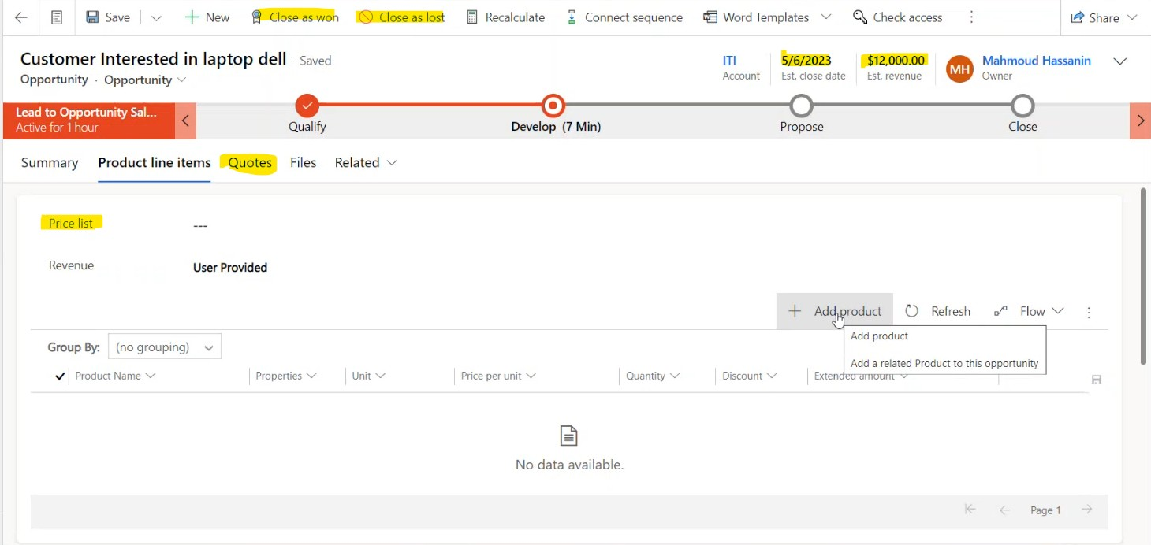

To add a product into opportunity you must add it into price list firstly. Also, you need to add your product as **price list** item.

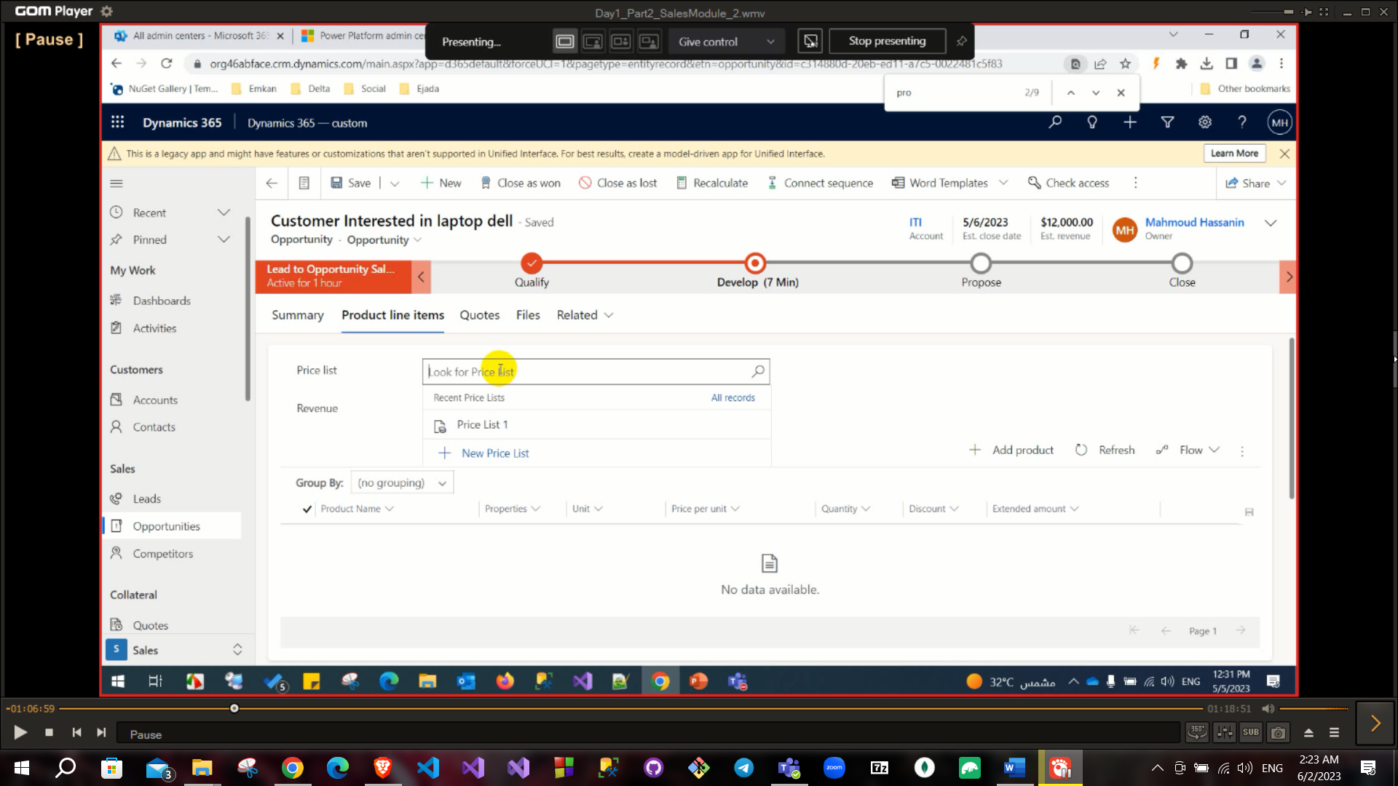

Discount List: set a condition to apply a discount. Family product: Like laptops in general.

Product: like laptop dell core i7. Bundle: Laptop with bag for example.

Unit group: For example you sell Television and you create an unit on this unit group is box and also create charger and television as a package (unit group is television, unit is box or package: television and charger).

When you publish a product its status transfer from draft to active and status reason will be in progress.

Then you can add this product to the develop part in the opportunity

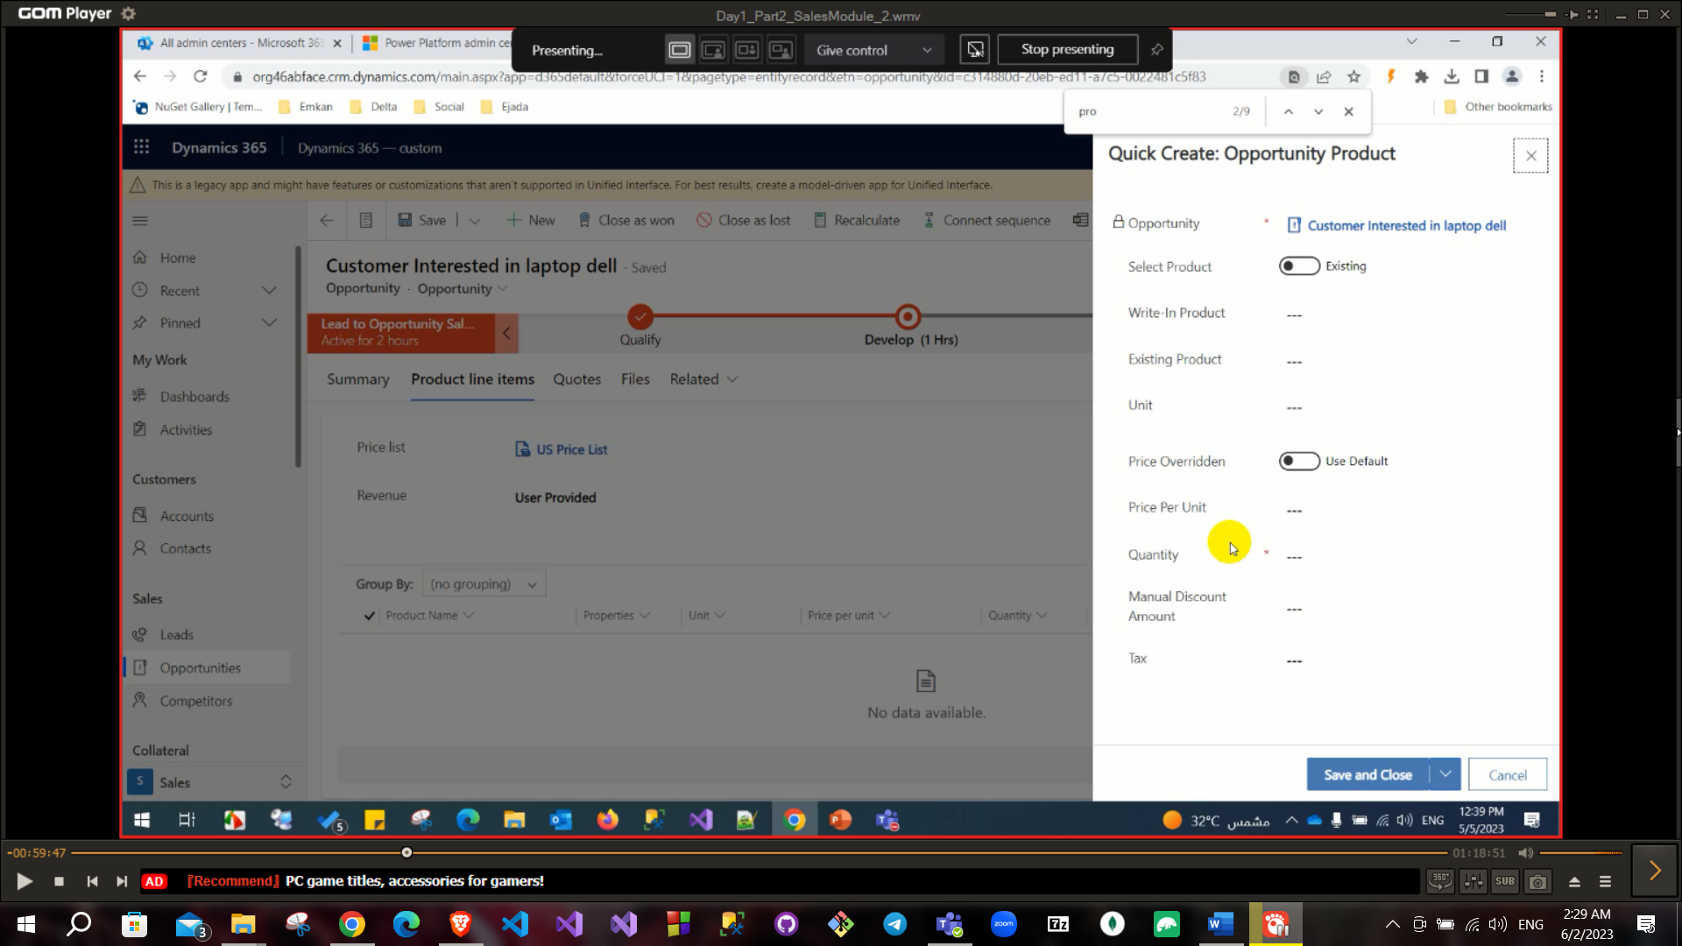

Also you can create price list and discount list.

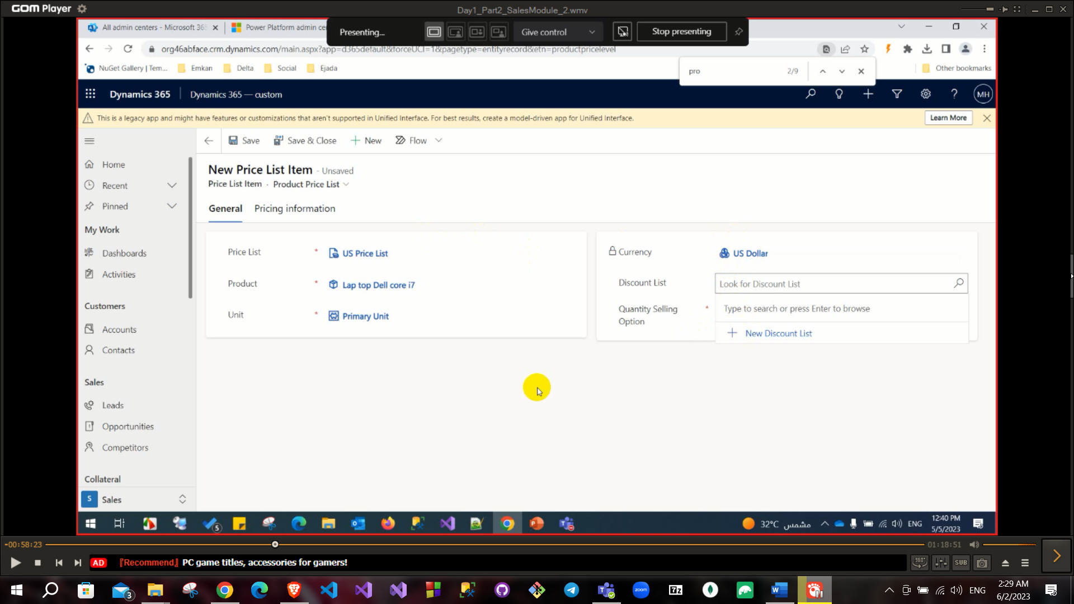

**At quote you can edit price too and can click on revise button.

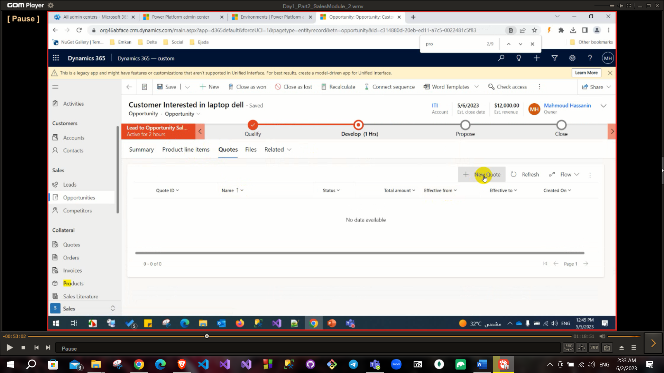After creating quote click on activate quote or close quote.

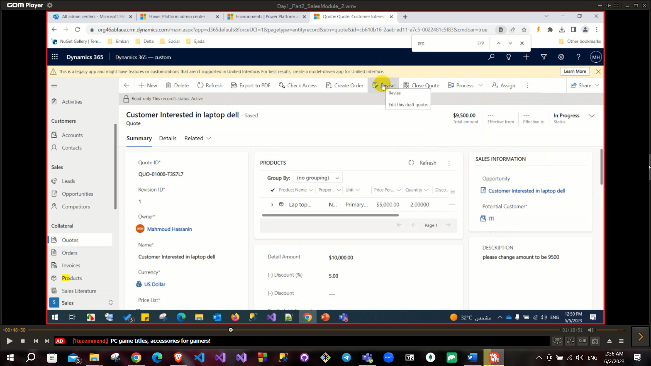

If the customer refused you can close the quote

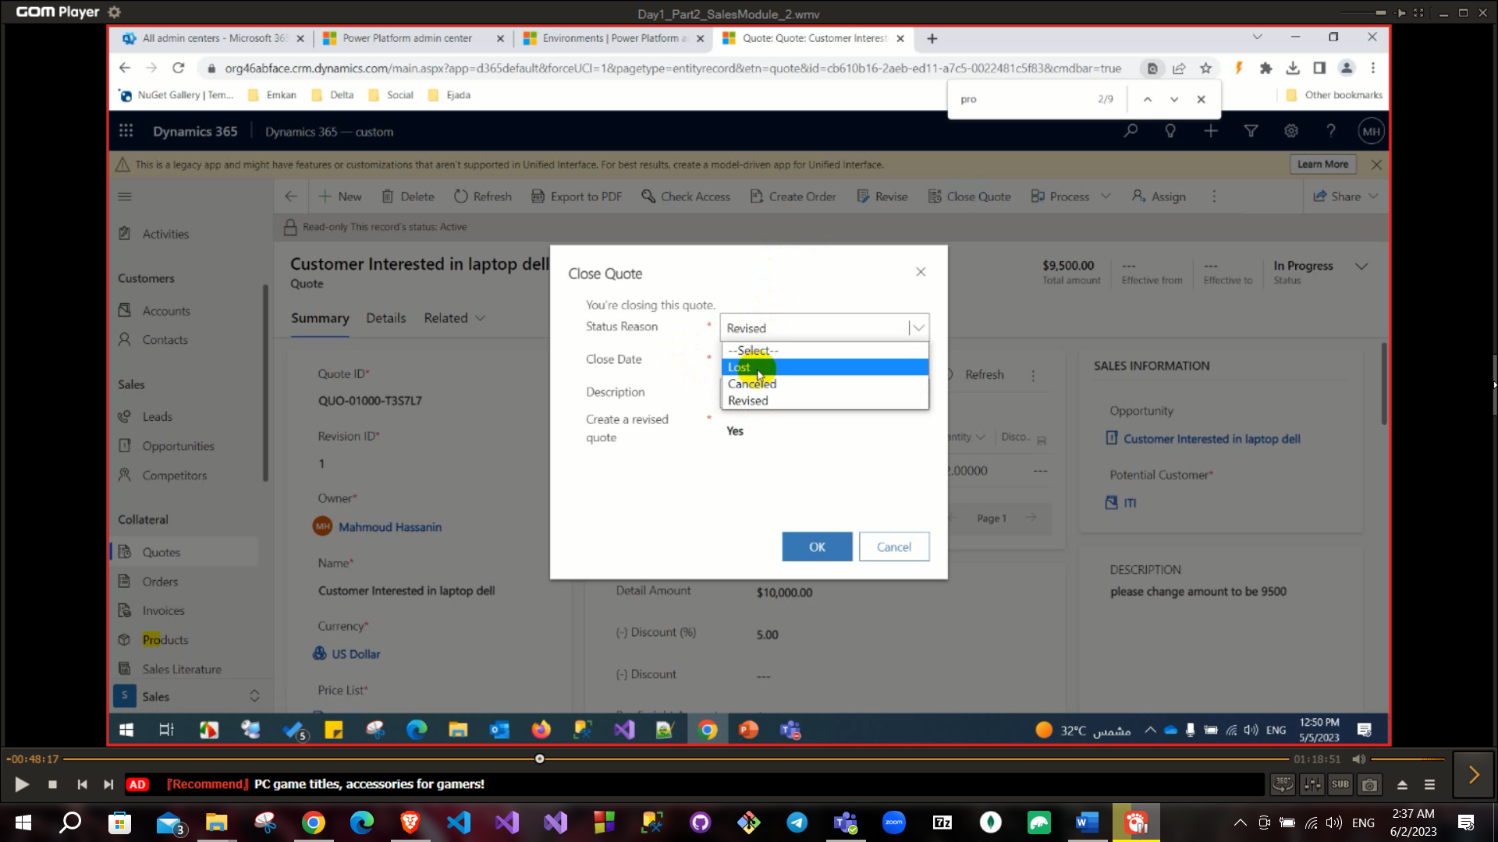

After activating quote click on create order button if the customer is okay

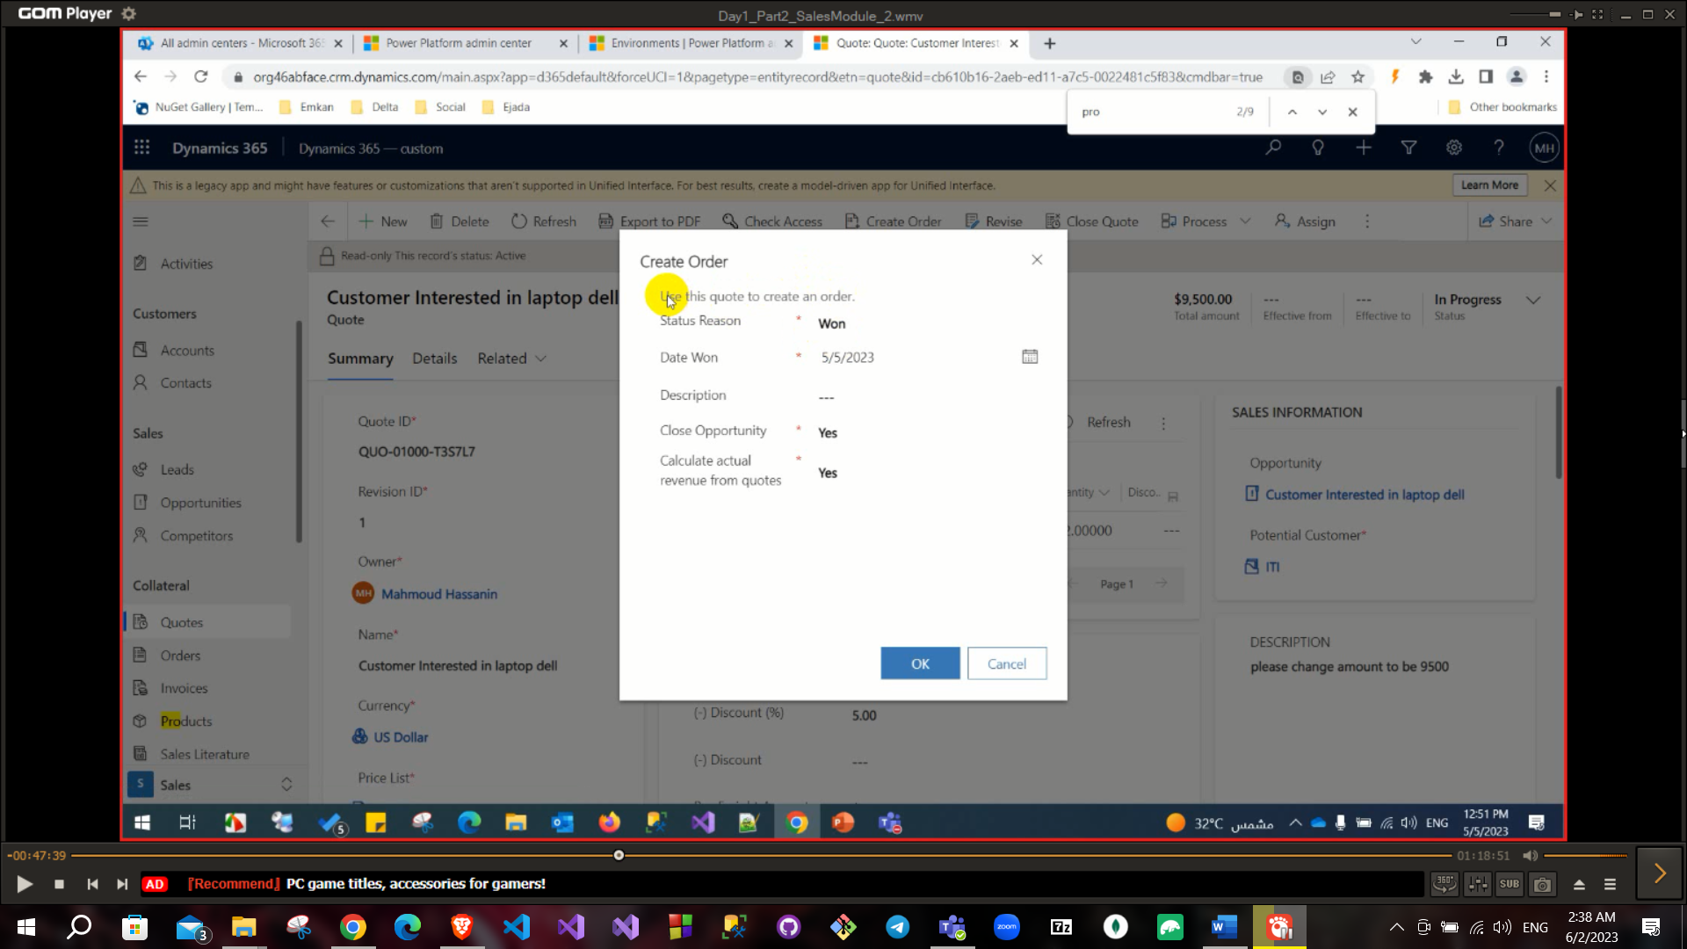

After creating order click on create invoice button. After creating invoice click on invoice paid button.

After clicking on invoice paid button status will be Paid and status reason will be complete.

System tracks closed records and open records from status. Paid invoice has two status reason (Complete, Partial).

# Important questions:

* Sales cycle:

Create lead → Qualify it to be Opportunity → create product → create price list →add your product into price list → Create quote → activate this quote → create Order → create invoice

* invoice status: paid or partially paid.
* order status: Fulfilled or canceled.
* Opportunity status: Won or lost.
* Lead status: Qualified or disqualified.